**HTML Links**

HTML links are defined with the <a> tag. For example:

<a href="http://www.google.com">This is a link</a>

The link address 'http://www.google.com' is specified in the href attribute.

Edit the 'index.html' document you just created and add the lines above like this:

<html>

<body>

<h1>This is a heading</h1>

<h2>This is a heading</h2>

<h3>This is a heading</h3>

<p>This is a paragraph.</p>

<p>This is another paragraph.</p>

<a href="http://www.google.com">This is a link</a>

</body>

</html>

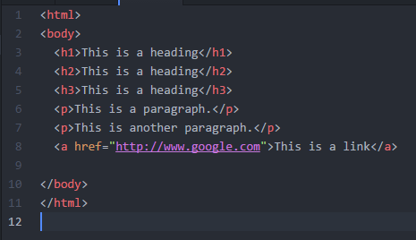

Save the file and refresh the page in your browser. It should look like this:

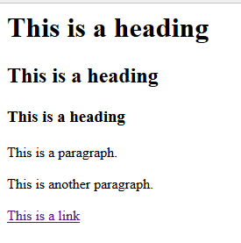

When you click the link, the URL will direct you to Google’s homepage.

**HTML Images**

HTML images are defined with the <img> tag. For example,

<img src=“flower.jpg" width=“274" height=“184" />

The name, 'flower.jpg' and the size of the image, width and height, are provided as attributes.

Edit the 'index.html' document again, and add the line above like this:

<html>

<body>

<h1>This is a heading</h1>

<h2>This is a heading</h2>

<h3>This is a heading</h3>

<p>This is a paragraph.</p>

<p>This is another paragraph.</p>

<a href="http://www.google.com">This is a link</a>

<img src=“flower.jpg" width=“274" height=“184" />

</body>

</html>

For the <img> tag to work properly, there needs to be an image file in the same folder, with the filename, 'flower.jpg'.